Buypass AS

Nydalsveien 30A, PO Box 4364 Nydalen

Tel.: +47 23 14 59 00

E
-
mail: kundeservice@buypass.no

N
-
Oslo, Norway
0402

Fax: +47 23 14 59 01

VAT: NO 983 163 327

INTEGRATION GUIDE
–

BP CODE

Check

P
oint R75
.x

–

R76

OPEN

Version

:
1.3

Document date:

14.02.2017

INTEGRATIONGUIDE

History of change

Version | Date | Status | Description/Change
1.0 | 11.03.2013 | Final | Document creation
1.1 | 30.05.2013 | Final | Minor changes
1.2 | 30.07.2013 | Final | Minor changes
1.3 | 14.02.2017 | Final | Upgrade

Contributors

Company name | Name
Buypass | Asmer Helez
Buypass | Espen Sammerud

Table of content

1 Configure Check Point with Buypass Code 2-factor authentication. 4
1.1 Technical requirements: 4
1.2 Configure BP code manager 4

Configure Check Point with Buypass Code 2-factor authentication.

Technical requirements:
- BPC service connector is installed and can communicate with LDAP server on TCP port 389 (ldap).
- Service account for LDAP query is created.

Configure BP Code Manager

Logon BP code manager with admin account.
https://www.buypass.no/bpcode/merchants/DINMERCHANTKODE/
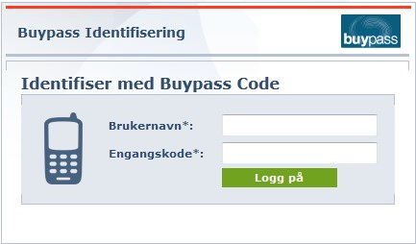

Configure LDAP server and LDAP path in meny ConfigurationLDAP
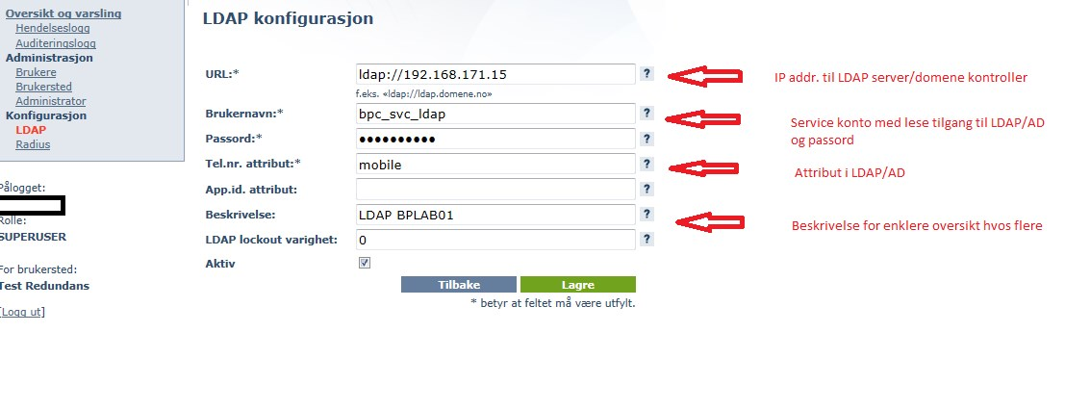

LDAP path(s).
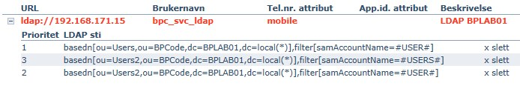
Several LDAP paths can be added in necessary. For recursive serach add (*) behind DC= (dc=local(*))

Add RADIUS client (Confkiguration → Radius → New configuration).
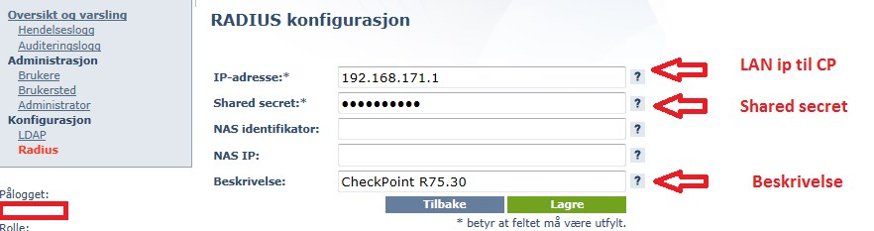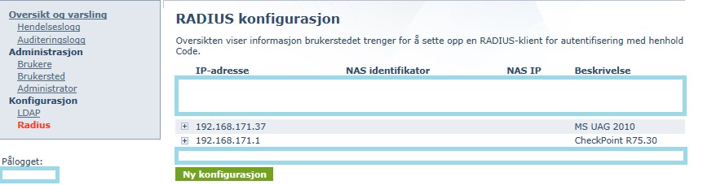

Logon Check Point SmartDashboard

Add new Host for BP Code service connector
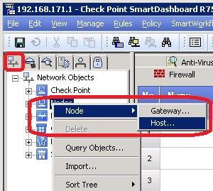

Type Host name, IP-address and description. Click OK
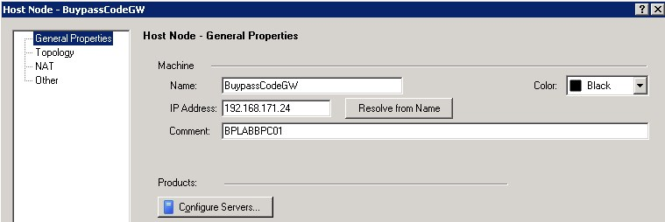

Click on “Servers and OPCSEC Applications” (1). Right click on RADIUS and choose New RADIUS (2)
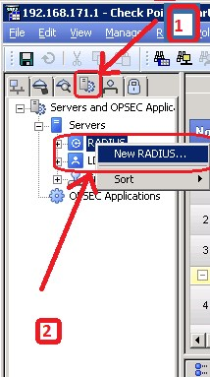

Enter: Name, Comment, Choose Host from P.6, choose service ”UDP NEW-RADIUS”, type in shared secret from P.4, choose RADIUS Ver.2.0 and PAP. Click OK

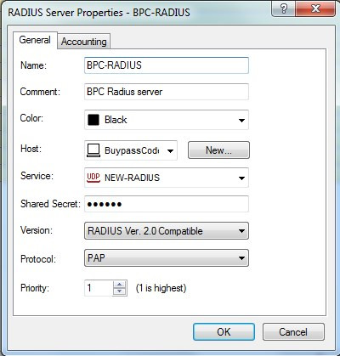

There are several ways to configure VPN user access in Check Point. Users can be authenticated directly in Check Point, using LDAP with AD, SecureID or using RADIUS. We will configure Check Point to authenticate users with RADIUS and BP code.

Browse to Manage → Users and Administrators → New → External User Profile → Match all users. This will create user “generic*”
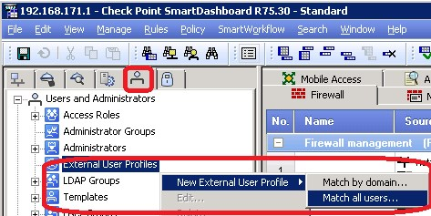

Enter Comment, choose RADIUS ”Authentication Scheme” and choose BPC Radius server configured in P.8. Click OK.
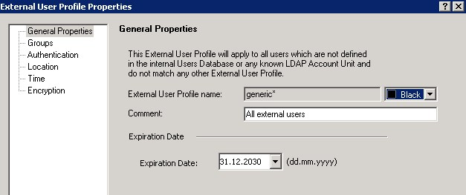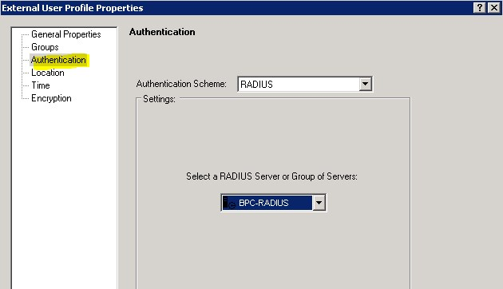

Create new VPN group (User Group)
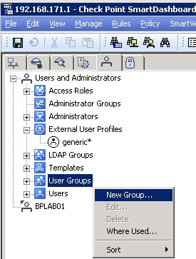

Enter group name. Add «generic*» in «Selected members». Click OK
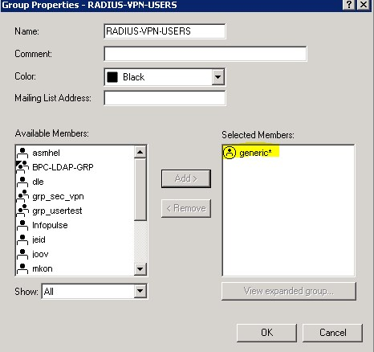

Click on VPN communities, right click Remote Access, choose Participating Gateways, add Check Point firewall object.
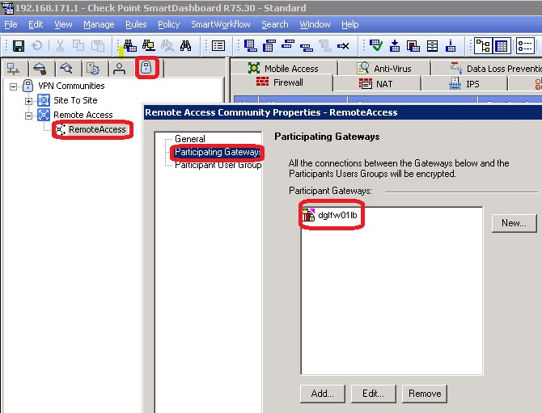

Click on Participant User Groups, Add group added in P.12. Click OK twice.
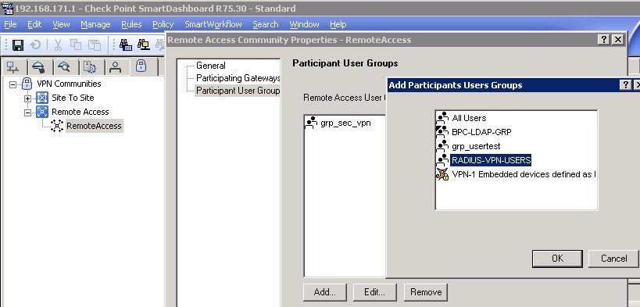

Cretae firewall rule (in necessary) to allow udp/1812 (new-radius) traffic from firewall to
BPC service connector.

Install Policy
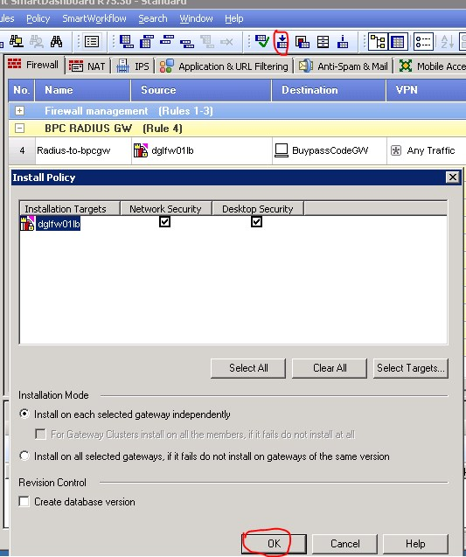

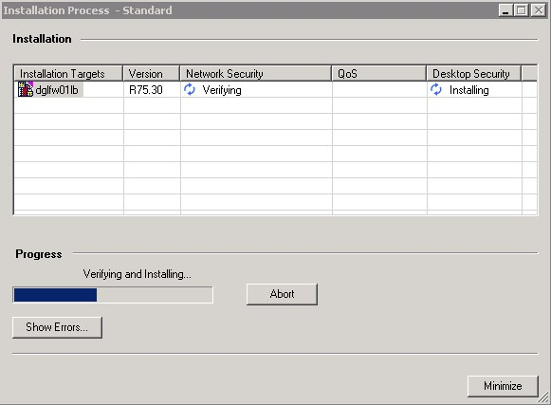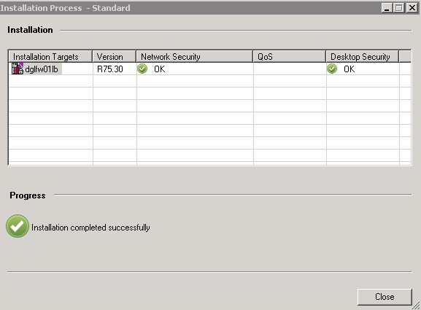

Configre Check Point client to use RADIUS for logon(Sites – Properties – Settings)
Choose ”Username and Password” for ”Authentication Method”.
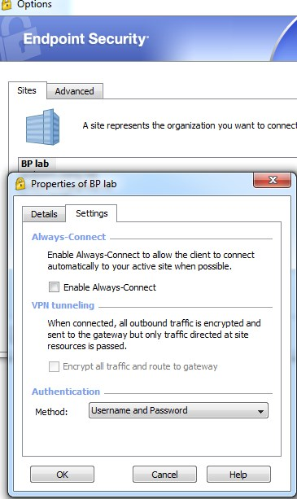
Enter username and OTP (one time password) from Buypass Code App. Click Connect.
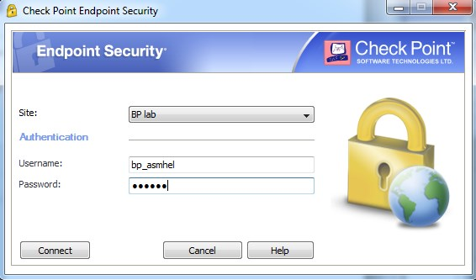

VPN koblet
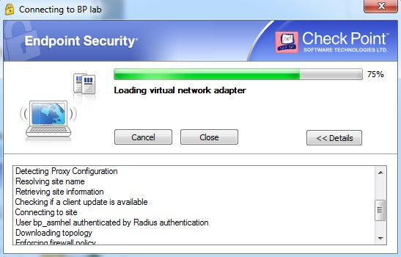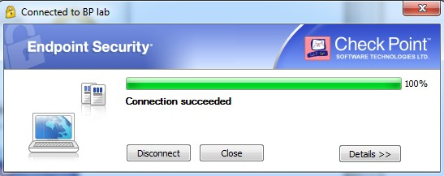

We can track logon activity in BP code manager.
