Integration Guide

Netscalerservice 10.x
BP Code

Buypass OPEN | Version: 1.0  Document date: 21.02.2017

History of change

Version | Date | Status | Description/Change
1.0 | 26.01.2017 | First version | First version

Contributors

Company name | Name
Buypass AS | Asmer Helez

Table of content

Overview 4
1.1 Technical requirements 4
Configure Netscaler with Buypass Code 4
1.2 Prerequisities 4
Requirements 5
1.3 Add Netscaler to Buypass Code Manager 6
1.4 Configure Netscaler with Buypass Code 7

Overview

Technical requirements

Configure Netscaler with Buypass Code

Prerequisities
- Netscaler configued with Active directory authentication
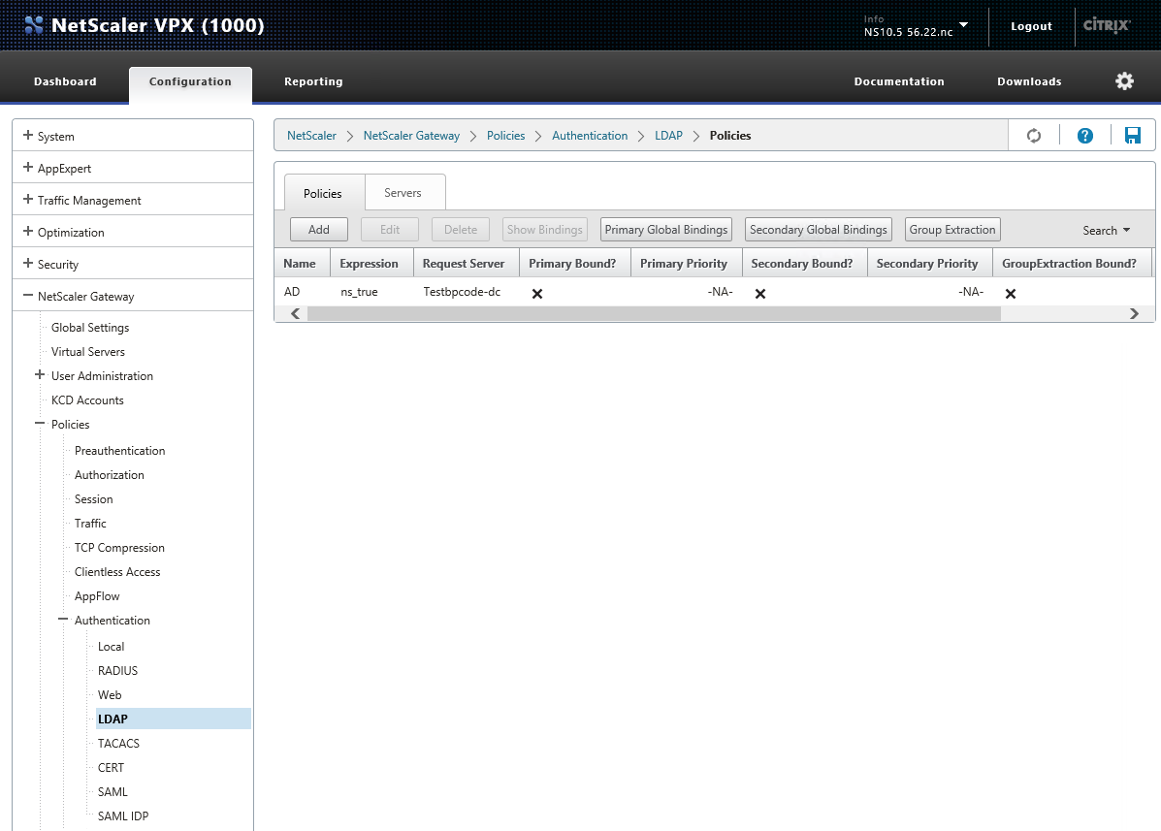
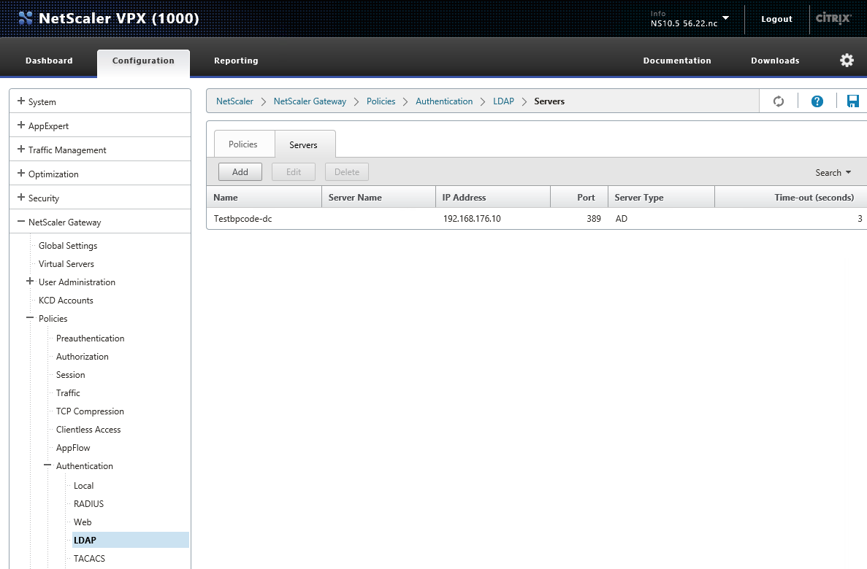
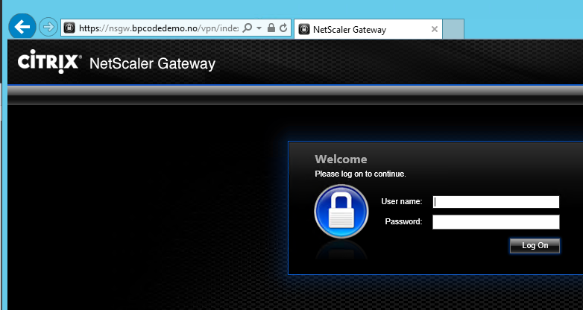

Requirements
- Access to Buypas Code Manager for dedicated merchant
- Buypass Code Service Connector installed according to guide:
https://buypassdev.atlassian.net/wiki/display/BpCode/Installasjonsguider?preview=/7405732/11436034/Service%20Connector8.0.X.X_installationGuide_EN_25.09.2014.pdf

Add Netscaler to Buypass Code Manager
- Log on Buypass Code Manager - browse to Configuration – click on RADIUS and click New configuration (ny konfigurasjon)
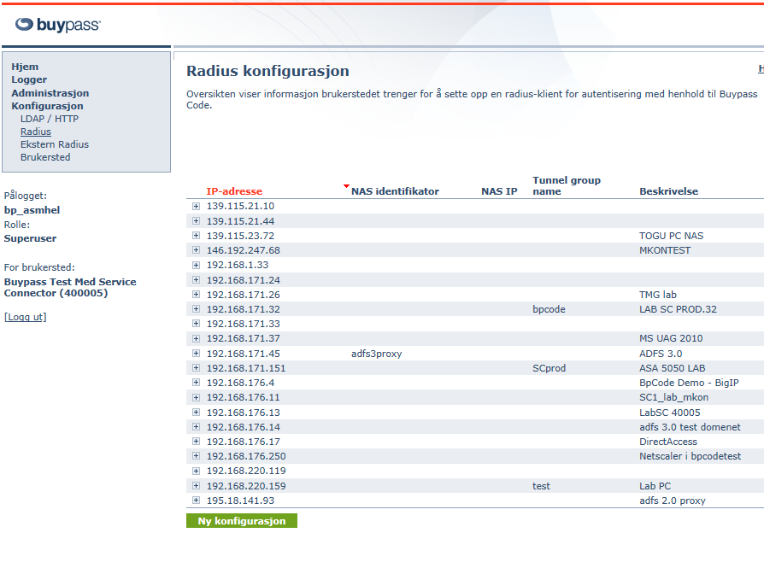

- Fill in ip address of Netscaler, shared secret and description. Choose LDAP container where users are homed. Click Save (Lagre)
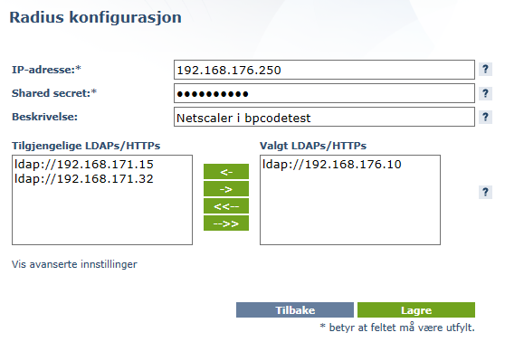

Configure Netscaler with Buypass Code
- Logon Netscaler, browse to SystemAuthenticationRADIUS and add RADIUS server
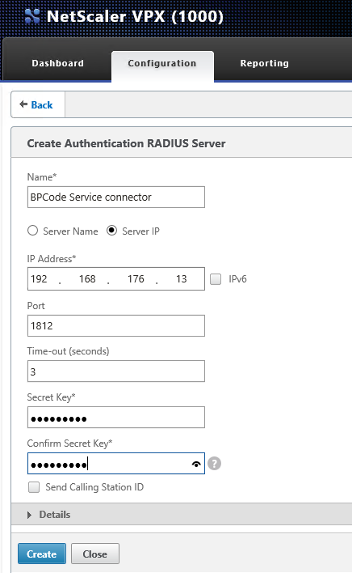

- Add Policy
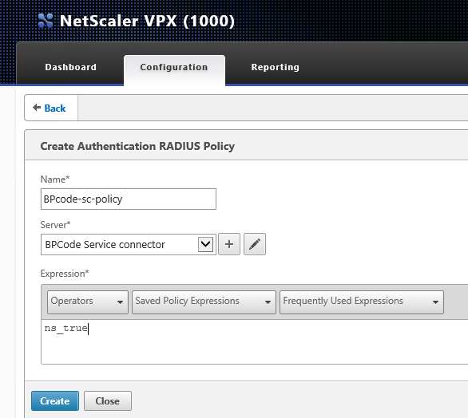

- Edit Netscaler GatewayVirual server
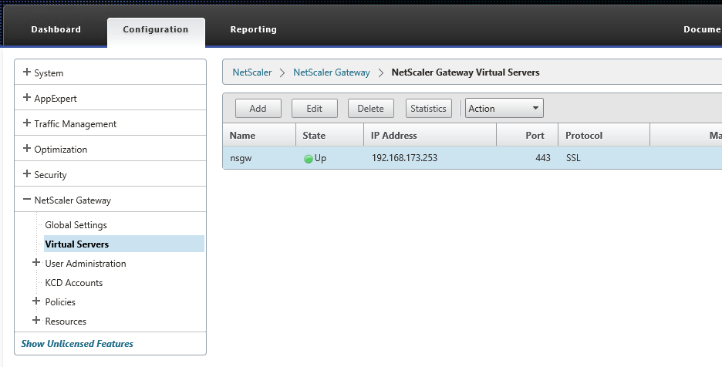
- Add authentication
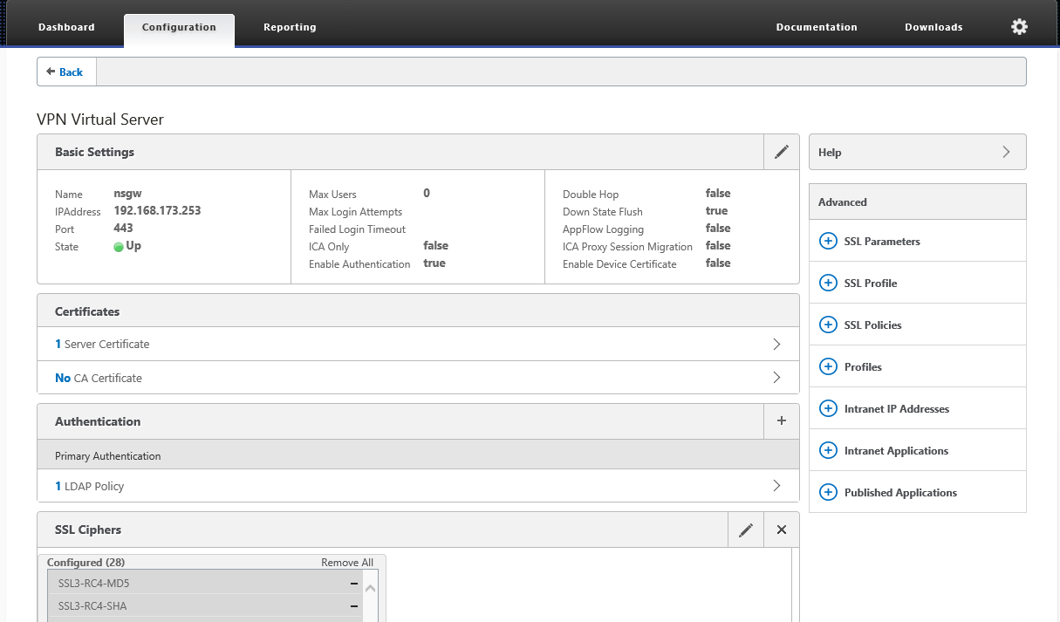

- Choose policy and type - secondary
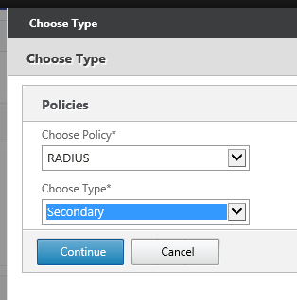

- Bind policy
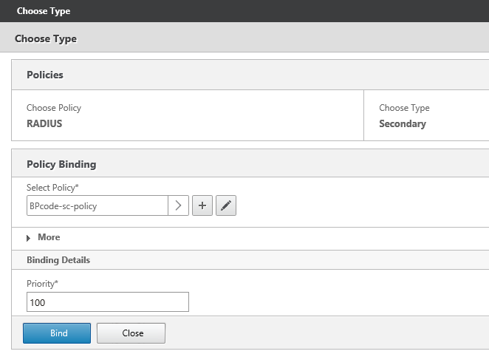
- Click Done
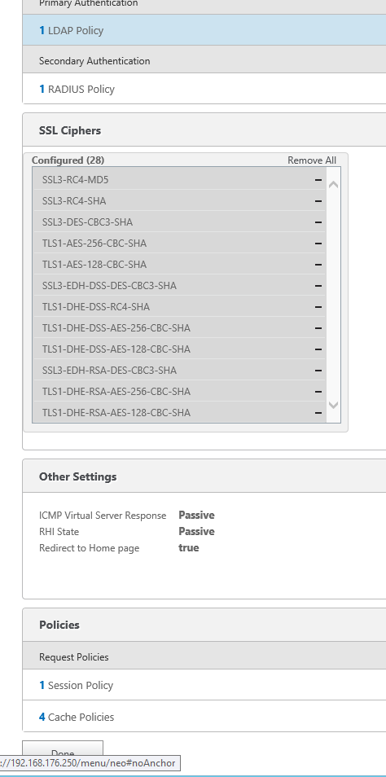

- Logon Netscaler with username, password and Buypass OTP
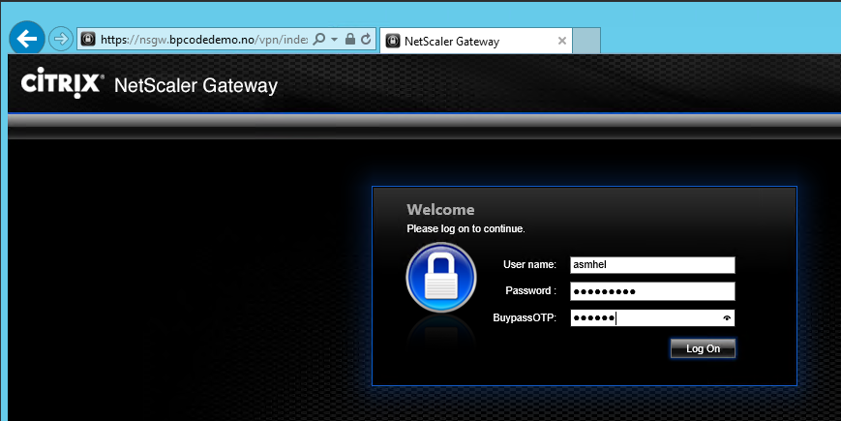
To customize logon page for Netscaler check https://support.citrix.com/article/CTX126206
- User is logged on
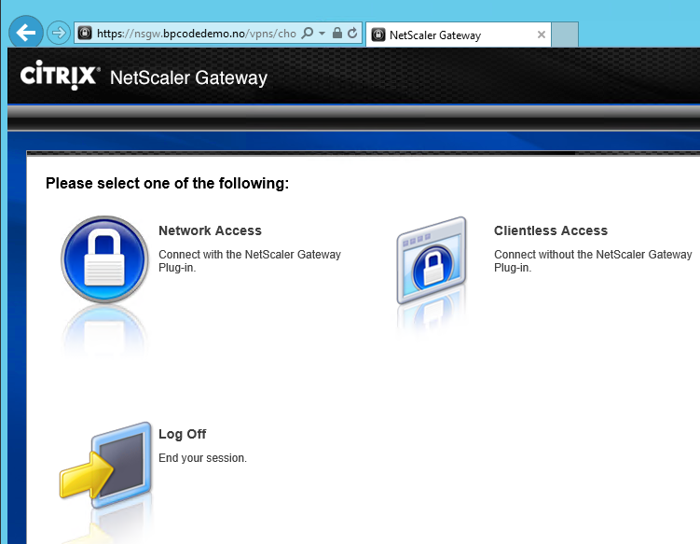

- Buypass Code Manager log
