Buypass AS

Nydalsveien 30A, PO Box 4364 Nydalen

Tel.: +47 23 14 59 00

E
-
mail: kundeservice@buypass.no

N
-
Oslo, Norway
0402

Fax: +47 23 14 59 01

VAT: NO 983 163 327

INTEGRATION GUIDE
–

BP CODE

Windows 2012 r2 Direct Access

OPEN

Version

:
1.0

Document date:

21.02.2017

INTEGRATIONGUIDE

History of change

Version | Date | Status | Description/Change
1.0 | 21.02.2017 | Final | Final

Contributors

Company name | Name
Buypass | Asmer Helez

Table of content

1.1 Technical requirements: 3
1.2 Configure BP Code Manager 3
1.3 Configure certificate templates 4
1.4 Test from the client 12

Technical requirements:
- Direct access must be configured and working
- Buypass Code service connector (BPSC) must be installed according installation guide for BPSC)
- Access to Buypass Code manager verified
- Service account in Active Directory for LDAP query
- Access to internal Certificate authority to configure necessary templates
- Radius port UDP 1812 open between Direct Access server and BPCSC
- LDAP port TCP 389 open between BPCSC and LDAP catalog severs
- HTTPS port TCP 443 open from BPCS to internet

Configure BP Code Manager

- Configure LDAP settings
  - Add new LDAP configuration
    - Add LDAP server IP or FQDN
    - Add service account with read access to LDAP catalog/Active Directory
    - Add name of attribute for mobile phone – AD attribute name is “mobile”
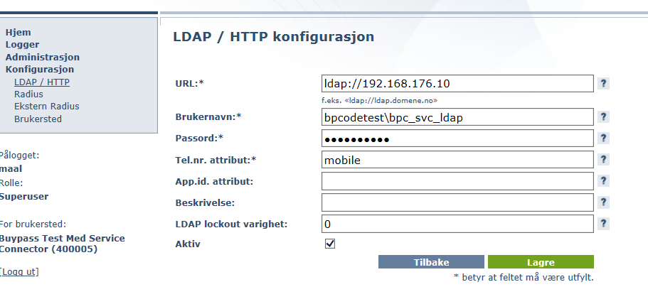
  - Add new LDAP path
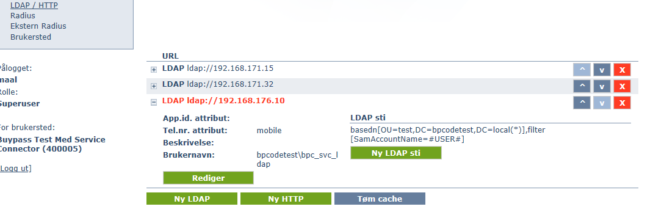

- Configure Direct Access as radius client
  - New radius configuration
    - Add ip address of Direct Access server
    - Add Shared secret
    - Type Description – ex “ Direct Access SERVERNAME”
    - Choose proper LDAP
    - Click on Advanced, choose can be monitored and configure DAProbeUser and DAProbePass
    - Save
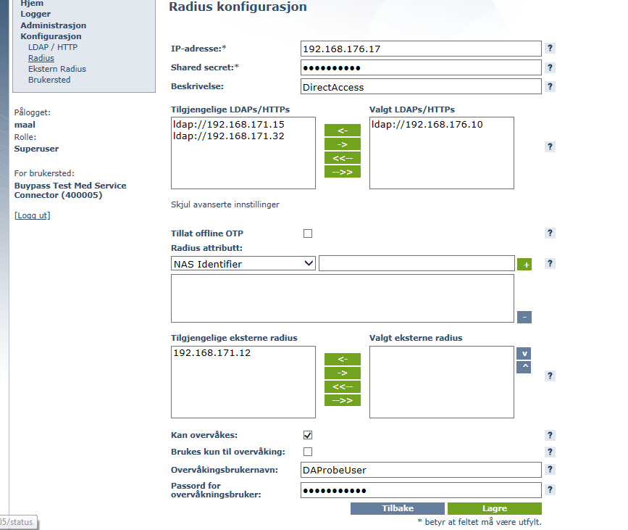

    - Check settings
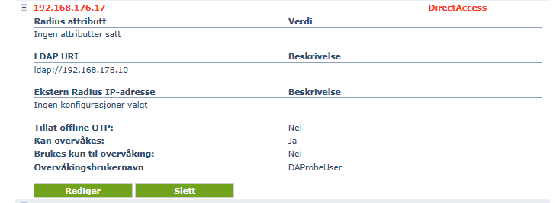

Configure certificate templates
- Configure OTP signing certificate template (registration authority certificate)
  - Start Certificate Template console – Startcerttempl.msc
  - Duplicate Computer template
  - Compatibility – Under Certification Authority, Choose Windows server 2012 or newer and under Certificate recipients Windows 8/Windows server 2012 or newer
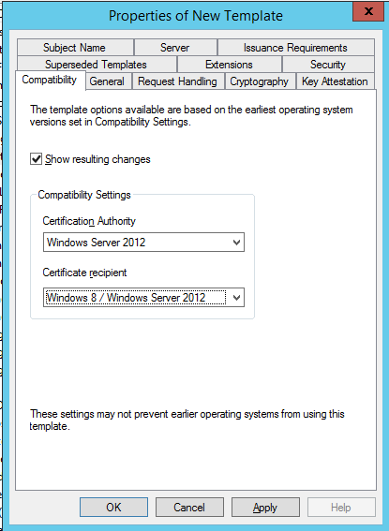
  - General – In Template display name, type BPCDAOTPRA, set validity period to 2 days and renewal period to 1 day.
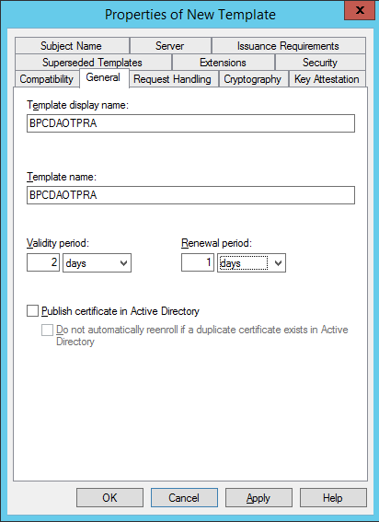

  - Security – configure following settings
    - Direct access server object: Allow READ, ENROLL and AUTO ENROLL
    - Authenticated users: allow READ
    - Domain admins: Allow FULL CONTROLL
    - Enterpise admins: Allow FULL CONTROLL
    - Domain computers: remove ENROLL from Allow
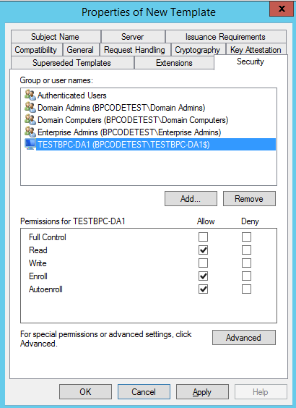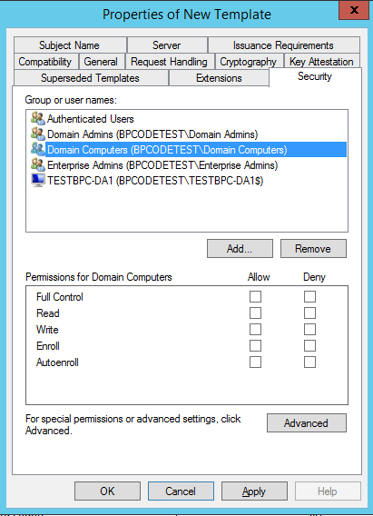

    - Apply

    - Subject name – Build from AD. Subject name format, choose DNS name. Check for DNS name box. Apply
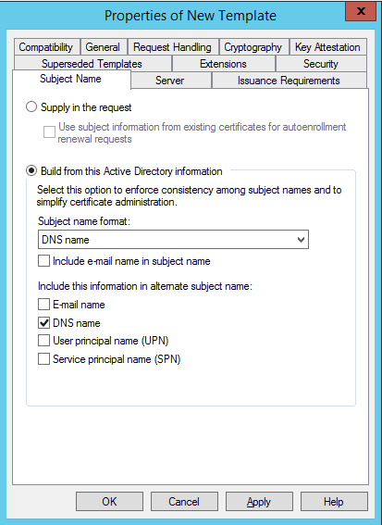

    - Extensions – Edit Application policy, remove all from the list. Add new- Name BPC DA OTP RA. In Object identifier field, type 1.3.6.1.4.1.311.81.1.1
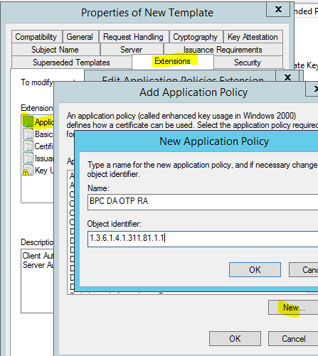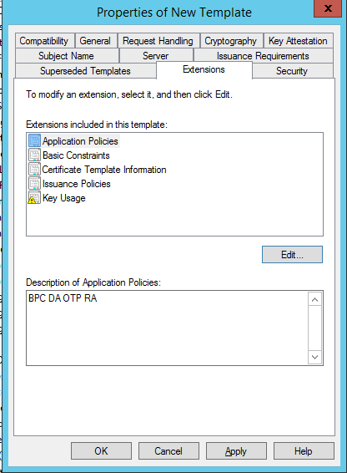

- Configure OTP logon certificate template (OTP authentication certificate)
  - Duplicate Smartcard logon template
  - Compability – Under Certification Authority , choose Windows Server 2012 or newer. Under Certificate recipients, choose Windows 8/Windows server 2012 or newer.
  - General – Type BPCDAOTPlogon in Template Display name. Set validity period to 1 hours and renewal period to 0 hours

  - Security – Configure following settings:
    - Authenticated users: Allow READ and ENROLL
    - Domain admins: Allow FULL CONTROLL
    - Enterprise admins: Allow FULL CONTROLL
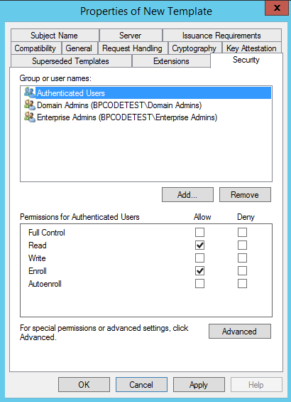
    - Apply

    - Subject name – Build from Active directory. Set Subject name format to fully distinguish name. Check box User Principal name (UPN).
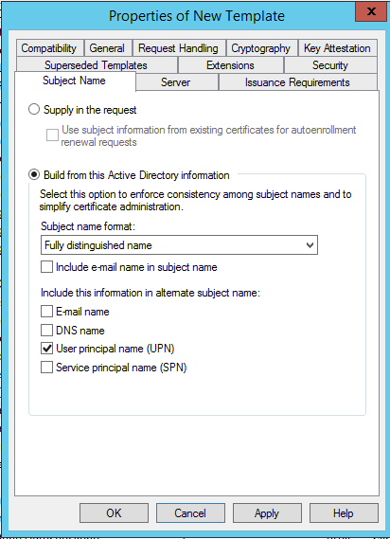
    - Server – Choose “Do not store certificates and requests in the CA database”. Remove mark from “Do not include revocation information in issued” certificate
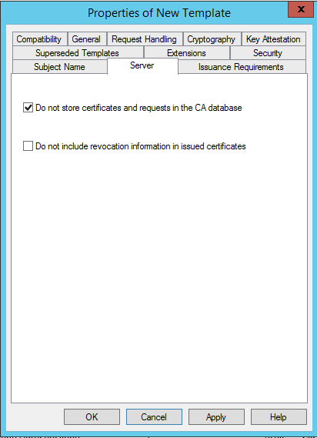

    - Issuance requirements – Set “This number of authorized signatures” to 1. Under Policy type required in the signature, choose Application policy. In Application policy, choose BPC DA OTP RA. Click Apply
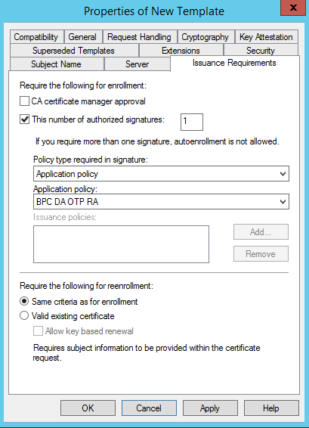

    - Extensions – Edit Application policies and remove Client Authentication. Click Apply
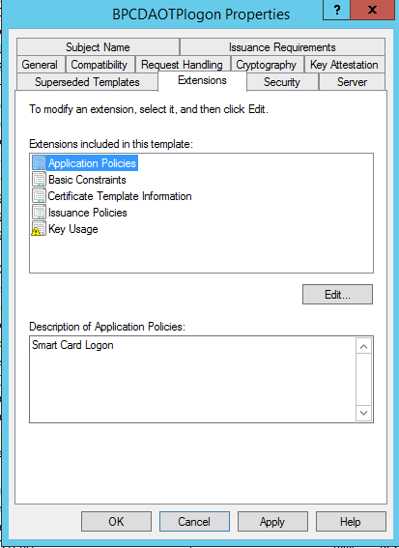
    - Cryptography – Minimum Key size 1024, Request must use one of the following providers: Microsoft RSA SChannel Cryptographic provider
Click OK
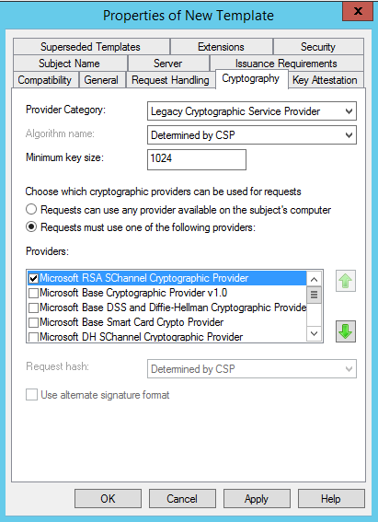

  - Chack that new templates has BPC DA OTP RA and Smart Card Logon under Intended Purposes
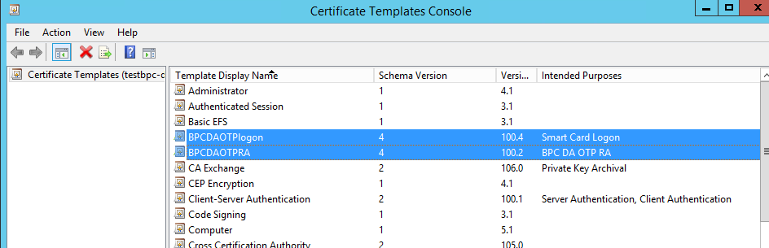

  - Publiseh new Templates
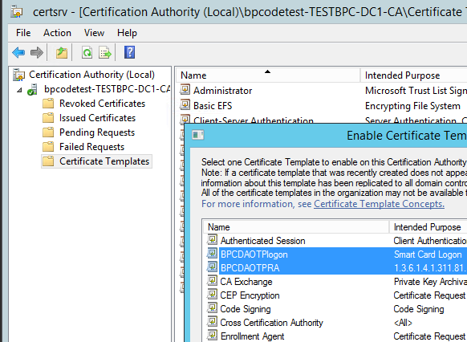
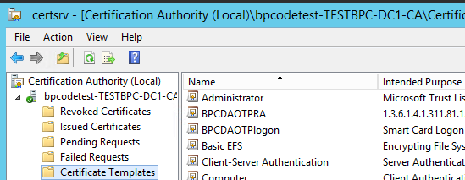

- Configure Direct Access with OTP
  - Start Remote Acces Management. Click Edit in Configuration Wizard, STEP 2
  - Click Next to get to Authentication
  - Choose Two-factor authentication and check OTP. “Use computer certificate” should be marked and proper issuing CA should be filled in. Choose if you want to enable windows 7 computers or not. Click Next.
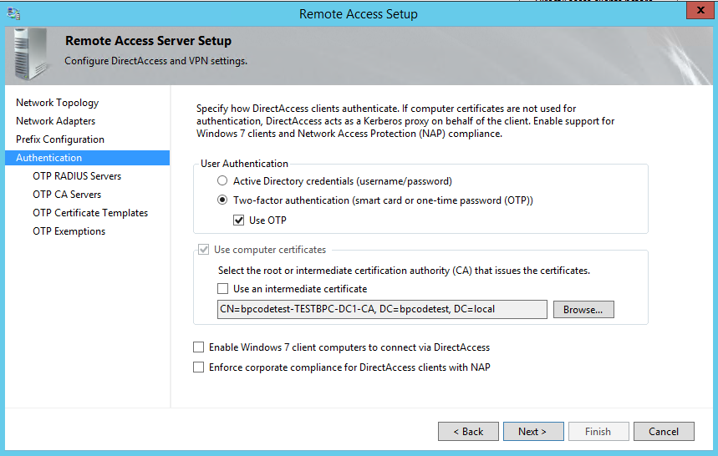

  - In Add radius, double-click first line and add ip address of BPSC. Click Change and add shared secret (same as configured in BP code manager). Port 1812. Click ok and next.
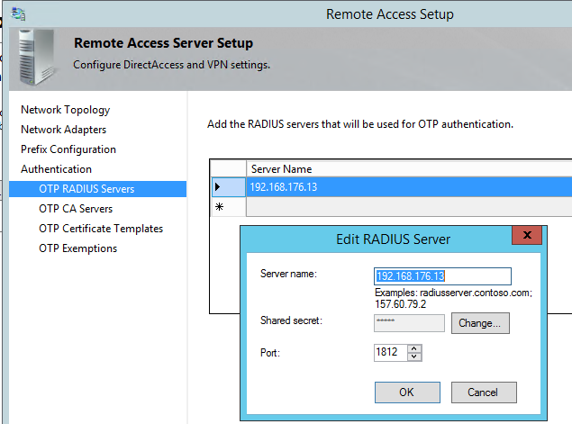

  - Add CA server
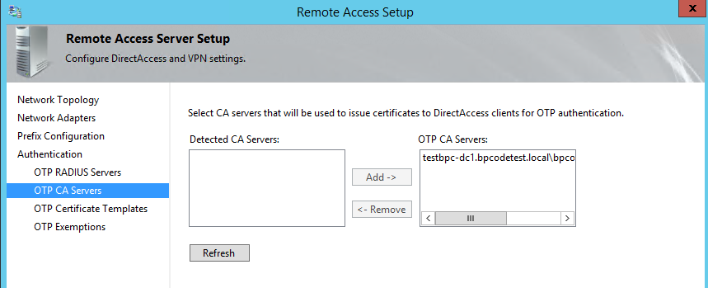

  - Choose BPCDAOTPLogon for OTP authentication and BPCDAOTPRA dor enrollment request. Click Next.
  - Choose if you want to exclude AD group from two factor authentication.
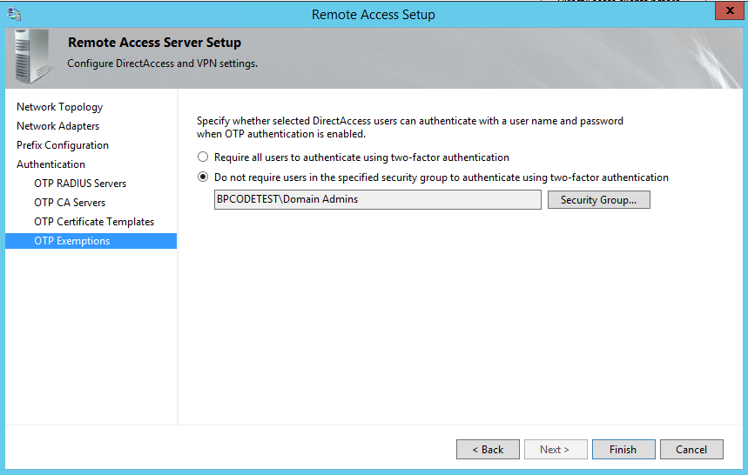

  - Under STEP 3 of Configuration wizard, add CA server I management section.
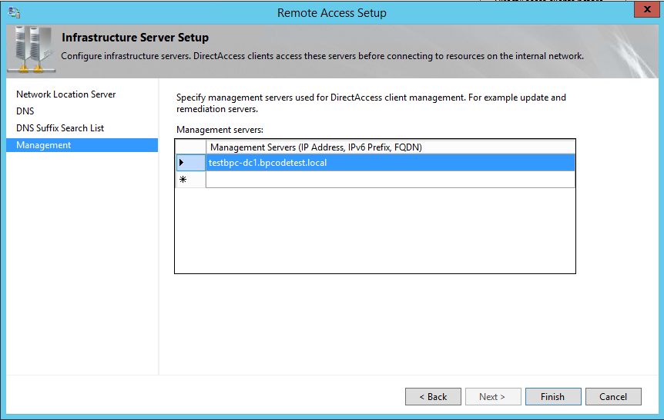

  - Use Powershell to configure Direct Access with OTP:
    - Set-DAServer -UserAuthentication TwoFactor
    - Enable-DAOtpAuthentication -CertificateTemplateName "BPCDAOTPLogon" -CAServer "testbpc-dc1.bpcodetest.local\bpcodetest-TESTBPC-DC1-CA" -RadiusServer 192.168.176.13 -SharedSecret Abcd123$ -SigningCertificateTemplateName "BPCDATPRA" –Verbose

Test from the client
- Logon Direct Access enabled PC outside of corporate network (homeoffice, LTE etc)

- Click on Network icon, click on Direct Access (Action Needed)
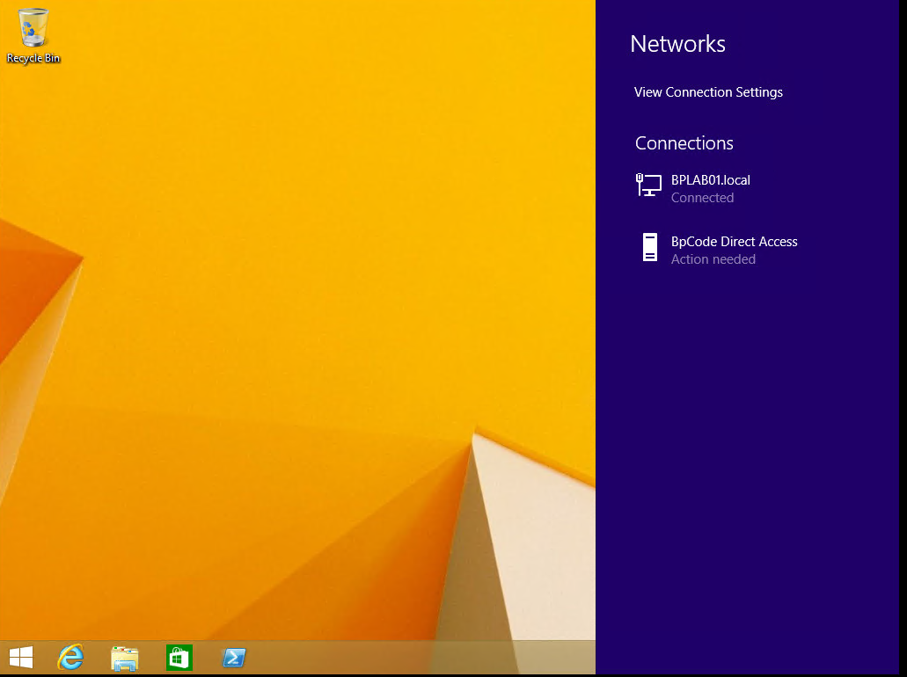

- Click Continue
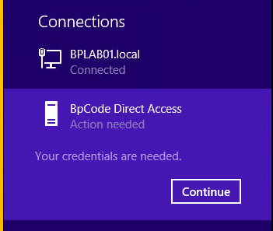

- Press CTRL+ALT+DEL
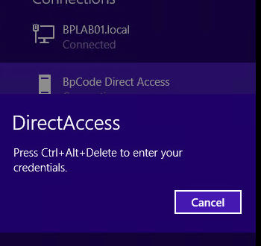
- Choose OTP and type code from BP code app. Click OK
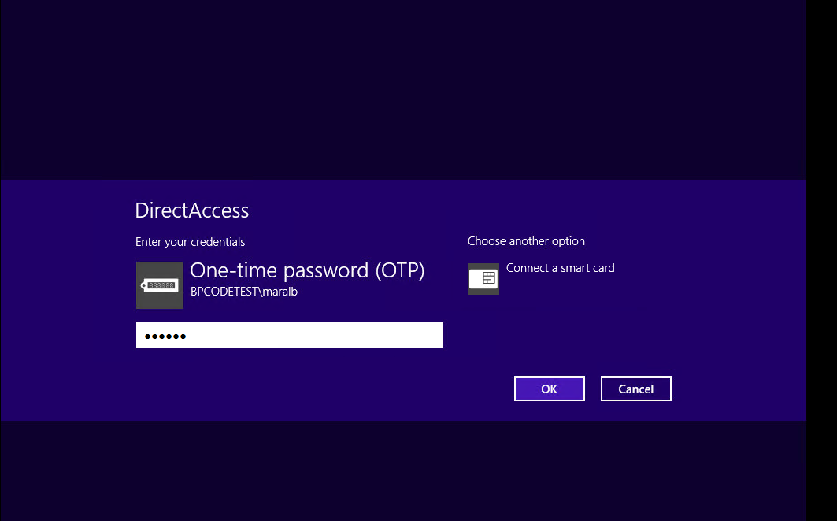

- User is authenticated and can access corporate resources
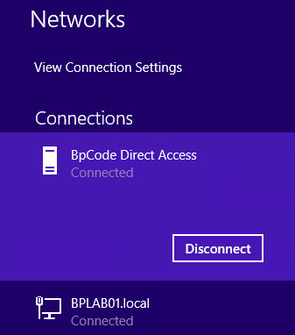

- Entry logged in BP code manager
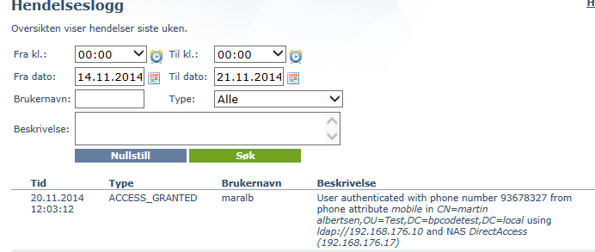
Microsoft reference:
http://technet.microsoft.com/en-us/library/hh831379.aspx - Deploy remote Access with OTP Authentication

